**Brooklyn torah gazette**

**For parshas pinchas 5780**

Volume 4, Issue 40 (Whole Number 192) 19 Tammuz 5780/ July 11, 2020

**Printed L’illuy nishmas Nechama bas R’ Noach, a”h**

**New Effort Launched to Identify And Catalogue Every Hebrew Book in Italy for First Time Ever**

***Some 35,000 volumes from dozens of communities and institutions across the country will be included***

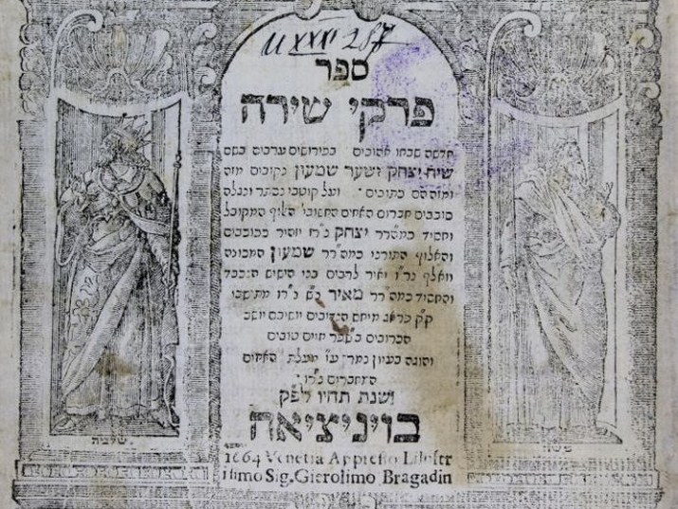

A ground breaking collaborative effort to create a unified listing of all Hebrew books in Italy for the first time ever has been announced by The Union of Jewish Communities in Italy (UCEI), the Rome National Central Library (BNCR), and the National Library of Israel (NLI) in Jerusalem. The “I-Tal-Ya Books” initiative is being made possible through the support of the Rothschild Foundation Hanadiv Europe.

Jewish communities have existed in Italy for more than two millennia and over the centuries it has played a critical role in global Jewish history, particularly as a significant center for manuscript production and printing.

[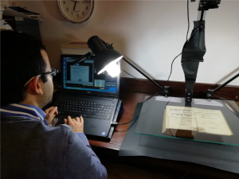](https://blog.nli.org.il/wp-content/uploads/2020/07/Foto-David-per-finale-report-4.png)

Today in Italy, thousands of uncatalogued rare Hebrew books dating back hundreds of years are held among collections belonging to local Jewish communities, as well as libraries owned by the state, the Italian Church Institutions (CEI) and the Vatican.

Some of the collections have been partially catalogued; however, there is no single integrated and standardized listing of these holdings and so while many of these books have significant historical importance and hold tremendous potential for scholars, they are often difficult if not impossible to find.

The “I-Tal-Ya Books” initiative will ensure the protection, preservation and provision of access to these cultural treasures as never before using technology developed specifically for the project. The Union of Jewish Communities in Italy (UCEI) will oversee the project, with the Rome National Central Library (BNCR) hosting the catalogue, and the National Library of Israel (NLI) providing the relevant training, support and expertise related to Hebrew books.

Dr. Yoel Finkelman, Curator of the Haim and Hanna Salomon Judaica Collection at the National Library of Israel commented: “As the national library for both the State of Israel and the Jewish people worldwide, we are honored to partner in the I-Tal-Ya Books initiative, sharing our expertise with colleagues in order to help identify and catalogue thousands of texts that would otherwise essentially be lost to history.”

[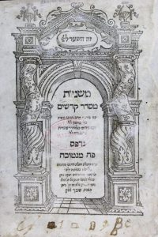](https://blog.nli.org.il/wp-content/uploads/2020/07/Presentation-Catalogue-Hebrew-Book-Italy-ph-09.jpg)[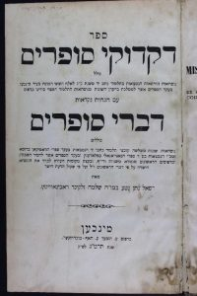](https://blog.nli.org.il/wp-content/uploads/2020/07/Presentation-Catalogue-Hebrew-Book-Italy-ph-04.jpg)

An initial pilot phase has just concluded, and the full-scale project starting now will include an estimated 35,000 volumes from 14 Jewish communities and 25 state institutions. It will take approximately three years to complete.

*Reprinted from the July 1, 2020 email of the National Liibrary of Israel*

**Rabbi Berel Wein on**

**Parshat Pinchas**

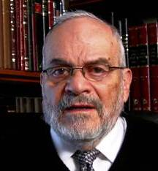

The Torah traces the lineage of Pinchas back to his grandfather Aaron. At first glance, there are no more disparate characters that appear to us in the Torah's narrative. Aaron is gentle and kind, compromising and seeking peace between differing people and factions, noble in character and beloved by all of Israel.

When Aaron passes from the world, the entire Jewish people without exception mourned his passing, and felt a great loss that his departure meant to them. Aaron was not only the first high priest of the Jewish people to serve in the tabernacle but was also the prototype for all later high priests that would occupy that position in future generations.

**A Zealot Who Rises to the Occasion**

In contradistinction to this assessment of character and behavior, the Torah describes Pinchas as a zealot who takes violent action against those who publicly defame and destroy Torah values and the Jewish people. He rises to the occasion by killing one of the leaders of the tribes of Israel.

He is criticized by the Jewish people for such behavior, and they attributed his conduct to his lineage. Pinchas was not only descended from Aaron but he also was descended from non-Jewish priests, and his violent characteristics are attributed to his non-Jewish grandfather. Yet, the Torah chooses to emphasize the priestly lineage of Pinchas and attribute his behavior and his response to the public defamation of God in Israel specifically to his grandfather Aaron.

**A Strong Lesson is Being Taught**

There is a strong lesson being taught with this nuance of lineage that appears in this week's Torah reading. We will find later in Jewish history, at the time of the Greek persecution of the Jews and of Judaism, that another descendent of Aaron, Matityahu, together with his family, also kills a renegade who defames the G-d of Israel and the Jewish people publicly by sacrificing to idolatry. Here we again see that within the holy and gentle character of Aaron and the priestly clan of Israel, there resides an iron will to stand strong against the defamation of everything that is holy and eternal.

When the situation demands it, the gentle priest becomes a man of war, who can and must take decisive and even violent action, to preserve the integrity of Torah and Jewish life. The Torah is generally not in favor of zealotry. However, as in the case of Pinchas, and later Elijah, sometimes zealotry is not only acceptable but necessary for Jewish survival. The problem always is how can a person measure whether the situation calls for such zealotry and even violent behavior.

**An Eternal Difficulty of Life is Presented to Us**

This eternal difficulty of life is presented to us. We can rarely be certain as to the correctness of our attitudes and behavior under a given situation or in response to a certain challenge. The Torah does not demand from us the wisdom of angels. But it does show us that there are different, even opposing responses, that are valid in difficult situations in both public and private life. The wise and holy person will be able to choose correctly.

*Reprinted from this week’s website of Rabbiwein.com*

**Rav Avigdor Miller on is**

**There Hope for America**

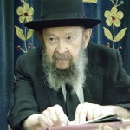

**QUESTION**: The Rav mentioned at the beginning of the lecture that it was because of its wealth that Mitzrayim became depraved. Does the Rav see a parallel in that with what’s happening in America?

**ANSWER:** This man is quoting me as saying that Egypt became decayed because of its great wealth. Certainly; there’s no question about that – it happened to all nations. The question is, is that happening to America today?

Absolutely. America is on the skids. America is going downhill rapidly. It's becoming so rotten and corrupt from the top to the bottom – morally and everything else – only because of too much prosperity. At one time all Americans believed in Hashem. I can testify to that – I remember when even politicians spoke about G-O-D; even politicians spoke about the hereafter. I remember that.  
 But today they are so corrupt that the word Hashem is no longer mentioned by anybody. And therefore Hakodosh Boruch Hu now is treating America like He treated all the old empires that went down into the dust.

Unless the people would try to get together to try to save America now and to throw out all the liberals. The liberals are the poison that's ruining America. If the people can wake up in the last moment before it's too late, then maybe they can save America. But America is right now on the way down the drain.

*Reprinted from the March 11, 2020 email of Toras Avigdor based on Tape #777 (April 1990).*

**Parshas Pinchas**

**A Land that Grows Immorality**

By Rabbi Bentzion Shafier

Founder of TheSmuz.com

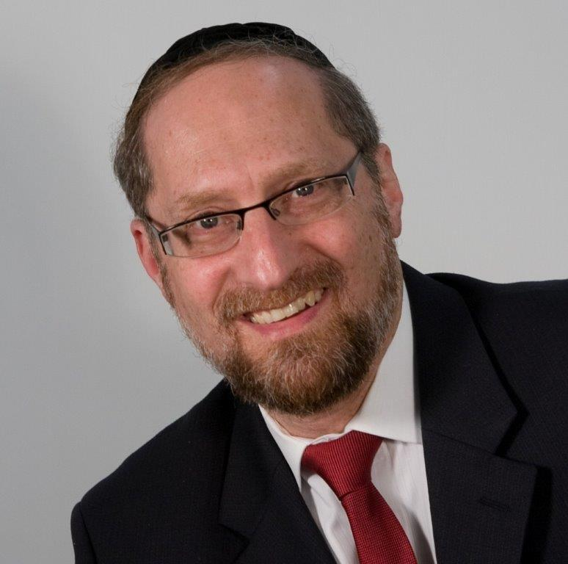

*“Yisrael settled in Shittim and the people began to act promiscuously with the daughters of Moav.”* — Bemidbar 25:1

Balak, the king of Moav, saw the supernatural success the Jews experienced when they left Mitzrayim, and he feared that his people would be destroyed. He hired the gentile prophet, Bila’am, to curse the Jews. HASHEM thwarted Bila’am’s efforts, and against his will, he blessed the Jewish people.

Recognizing that he couldn’t curse them, he gave Balak an alternate strategy: “Their G-d hates promiscuity. Entrap the men in sin, and G-d will destroy them.” Balak sent the message out to the Moabite women, and thus began one of the lowest descents in our history. In the end, 24,000 Jewish men were involved in sin and were killed by plague.

When setting the backdrop for these events, the Torah mentions that the Jewish people camped in Shittim. This fact seems to be irrelevant. What difference does it make where they stopped?

Rabbenu Bachaye explains that the city of Shittim was pivotal in these events, and it was only because the Jewish people were encamped in that area that the entire debacle unfolded. He explains that in Shittim, there was a stream of water that caused people to act immorally. This stream fed Sodom, and that was why people there became so depraved. The Torah mentions Shittim to let us know that it was because of that particular location that the Jews fell to that low level. The area was infused with a negative force.

This concept is very difficult to understand. How can a stream of water cause immorality? How can one place be more depraved than another simply because of physical attributes like a stream?

The best way to understand this is to focus on almost an opposite phenomenon.

**A Legend in Our Times**

In the annals of recent Jewish history, one of the shining stars was a man named R’ Meir Schuster. He became a one-man kiruv dynamo and is credited for tens of thousands of Jews returning to Torah. At his funeral, R’ Noach Weinberg, zt”l, himself an icon in the ba’al teshuvah movement, said, “I am jealous of R’ Meir’s olam ha-ba.”

But those who knew him as a young man in yeshivah said they never would have expected it of him. He was a humble, soft-spoken, and shy person. He was not particularly charismatic, nor was he a great speaker.

**Noticed that Many Visitors were Visibly Moved**

R’ Schuster’s ascent to the level of legend began in 1968 when he was a young *kollel* student who had just moved to Israel. He and his friend Chaim Kass went to daven at the *Kosel*, and they noticed many people there who had no connection to Judaism. Nevertheless, these people were visibly moved simply by being there. The thought struck them both: “Why can’t someone connect with all these Jews whose *neshamos* are lit up by the *Kosel*?” But sadly, there was nothing in place to help them explore what they were missing.

All of that changed when they noticed a young man wearing a backpack, leaning against the Kosel, and crying. Chaim walked over to him and asked if he would be interested in learning more about Judaism. The young man responded that he would.

For the next two weeks, R’ Meir Schuster and R’ Chaim kept returning to the Kosel to try to interest more people in exploring Judaism. By nature, R’ Schuster is particularly quiet and reserved, an introvert not naturally given to conversation, and so R’ Chaim initially did the talking. Within a couple of weeks, however, R’ Schuster began to take the lead.

And for the next forty years, R’ Meir Schuster was at the Kosel, inviting young men and women to experience a Shabbos and explore their heritage. He became known as the “Man of the Wall.” And, today, thousands and thousands of ba’alei teshuvah credit their return to him.

**Capturing the Moment**

But what was his secret? How did a shy, unassuming man accomplish so much? Certainly his sincerity and burning love for every Jew propelled him. But it was the time and the place that made it happen. Standing in Yerushalayim, the holiest city in the world, and there at its epicenter, the place of the Beis HaMikdash, a Jewish heart is aglow. The aura is pervasive and powerful. Rabbi Schuster tapped into that experience and guided people to further explore its wonder. What he did was gargantuan, but it was the Kosel that moved them.

**A Stream that Causes Immorality**

This seems to be the answer to Rabbenu Bachaye. “The land of Shittim caused immorality” is literal. There was a pull to depravity in that place. HASHEM created many forces in this world; some function on a physical plane, and some on a different plane. If you electrify a piece of iron, it exerts an electromagnetic pull — a force so powerful that it can lift a full-sized SUV. So, too, HASHEM created forces that affect the spiritual world.

Yerushalayim is infused with holiness; there is a presence in the air. When a person walks the streets, his soul lights up, and the pull toward ruchniyus is palpable. But just as HASHEM created specific places that effuse kedushah, He also created places that give off the opposite effect. There are places on this planet that exert a potent force that pulls a person to vice. It strengthens the hold of the body over the neshamah, and a person is drawn to do that which is sinful — not for the pleasure alone, but for the immorality of the action.

**San Francisco**

This concept is applicable to us, as even today, there are cities that are notorious for depravity. While we may be tempted to explain it based on sociological factors and circumstances, there is often a deeper, underlying cause. As part of keeping everything in this world in balance, HASHEM chooses some areas to be receptacles of impurity.

By being aware of different spiritual forces, and by becoming more sensitive to these pulls, we can tap into the dynamics that will propel our spiritual growth. May HASHEM speedily redeem us, and may we all live again in the most holy of all lands, our birthright, Eretz Yisrael.

*Reprinted from this week’s website on TheShmuz.com This is an excerpt from the*[*Shmuz on the Parsha book*](https://theshmuz.com/product/shmuz-on-the-parsha-book/)*.*

**The Importance of the Mitzvah Of Conquering the Land**

From the Talks of the Lubavitcher Rebbe

Rabbi Menachem Mendel Schneerson, Zt”l

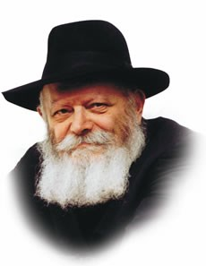

This week's Torah portion, Pinchas, details the manner in which the land of Israel was to be apportioned between the twelve tribes.

The Torah states: "According to the mouth of the lot shall the inheritance of each be divided."

Our Sages explain that the words "mouth of the lot" are to be taken literally, commenting that "the lot itself would cry out and announce, 'Such and such borders are designated for this particular tribe.' "

Axiomatic in Judaism is the principle that G-d never performs even the tiniest miracle without reason. Why then was it necessary for the natural order of the world to be abrogated and for the lot to speak? Why wasn't a "regular," non-talking lot sufficient to divide the land?

Although the lot may seem to be only a technicality in the decision-making process, the fact that it is emphasized so frequently in the Torah indicates that, in actuality, it has far greater significance.

When the Torah states that "nevertheless, through the lot shall the land be divided," its intent is that solely through the means of the lot shall it be divided, and not in any other manner.

In order to make this point absolutely clear to all, a miracle was necessary.

And yet, this explanation is not completely satisfactory, as the directive to apportion the land by lot was not issued as a specific mitzva of the Torah. The lot was, after all, only the method by which the land was divided.

However, it must be understood that every aspect of Torah has a Divine purpose. Thus, even one's preparations to perform a mitzva take on added significance.

Because the Torah states many times that the land was to be divided by lot, the lot itself had to be perfect in all details, including the choosing process itself --- the epitome of which occurred when the lot spoke up and announced the results!

"Conquering the land" is an eternal concept applying in every age and place.

A Jew is obligated to "conquer" the physicality of Creation and transform it into "the land of Israel" --- a vessel for holiness.

This service must be complete in two respects: all of the land must be conquered, i.e., no aspect of the physical world is to be left outside the realm of holiness, and the conquest itself must involve all of a person's capabilities, i.e., his thought, speech and deed.

Furthermore, the Torah teaches that the Jew must make no distinction between this service and the preparations that are made for it. Even the tiniest detail of our service of G-d contains a higher significance, and must be performed with the utmost care and in the most perfect manner.

"Conquering the land" in this manner serves as preparation for the ultimate settlement of the entire land of Israel, with the full and final Redemption with Moshiach.

*Reprinted from the Parshat Korach 5755 edition of the Lubavitch Youth Organization. Adapted from Likutei Sichot of the Rebbe, Vol. 2*

**The Daily Work of Marriage**

**By Rabbi Joey Haber**

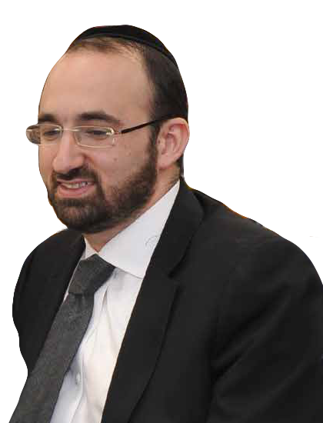

The Torah in Parashat Pinhas tells of the daily *korban tamid* – the sacrifice that was offered in the *Bet Ha’mikdash* each and every day.  Every morning and every afternoon, 365 days a year, this sacrifice was offered.

In order for us to build a relationship with Hashem, we need to put in work and effort, and make sacrifices, EACH AND EVERY DAY.

And this is true of all our relationships – most importantly, of marriage.

There are a number of different reasons why the divorce rate is rising at an alarming rate. One reason is that young people are told to try to find a spouse who meets certain qualifications, but they are not taught to build their characters so they will be good wives or husbands. Another reason is that people go into marriage without doing sufficient research, and so the boy or girl is not the person they thought they were getting.

**Many People Have No Clue What Marriage Really Is**

But the main reason, in my mind, is that people today have no clue what marriage really is.

Marriage takes work. Consistent work. In order to enjoy the unparalleled joy of a happy marriage, both partners need to continue working at it.

When the angels visited Avraham Avinu’s tent, as Avraham served them a meal, one of them turned to Avraham and asked where his wife, Sarah, was. Avraham replied that she was inside the tent. The Rabbis explained that the angel wanted Avraham to appreciate Sarah’s modesty, how she remained in the tent.

**Marriage Needs Work All the Time**

**And an Every Stage in Life**

Avraham was 99 years old when this happened.  And Sarah was 89. They had been married for decades. But the angel still wanted Avraham to appreciate Sarah a little more. Marriage needs work all the time. At every stage. Day in, and day out.

The great challenge of marriage, which requires so much work and effort, is that the spouses need to understand each other. A husband and wife need to feel confident that the other is trying to understand him or her.

Sometimes people love receiving advice from their spouse, and sometimes they hate it and resent it. Usually, the difference is whether the advice was given with understanding. What is needed is not just sincerity, but understanding. If the advice is offered off-the-cuff, without the spouse really trying to understand the other spouse’s situation and feelings, then it will be rejected. But if the advice is given with a real understanding of the other spouse’s situation, then it will be warmly accepted.

**The Connection Between Peace and Complete**

The word שלום, peace, is associated with the word שלם – complete. A husband and wife enjoy peace when they complete each other. And in order for this to happen, they need to put in the time and effort to really get to know each other and really understand each other.

Like the relationship between us and Hashem, the relationship between husband and wife is a day in, and day out, investment. Let’s put in the work so our marriages will work. Let’s make a commitment to really try to understand and connect with our spouses so we can build truly happy and fulfilling homes that are worthy of Hashem’s presence and Hashem’s blessings.

*Reprinted from this week’s iTorah.com website.*

**Why Isn’t Poultry**

**And Dairy Kosher?**

**By Rabbi** [**Yehuda Shurpin**](https://www.chabad.org/search/keyword_cdo/kid/15169/jewish/Shurpin-Yehuda.htm)

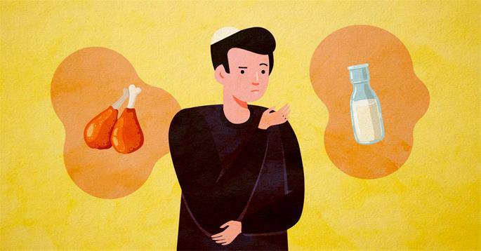

**Art by**[**Rivka Korf Studio**](https://www.chabad.org/4375450)**, a Miami-based art design studio**

This prohibition of separating milk and meat is derived from the verse "Do not cook a kid (*gedi*) in its mother's milk,” which is repeated three times in the Torah.[1](javascript:doFootnote('1a4788772');) The sages explain that the repetition of the verse teaches us that not only is one forbidden to cook meat and milk together, but one is also forbidden to eat or derive benefit from such a mixture.[2](javascript:doFootnote('2a4788772');)

Although the verse uses the Hebrew word *gedi*, which is usually literally translated as “kid goat,” in this context, the word actually means any young domestic animal. The sages explain that the Torah simply gives an example of a "kid in its mother's milk" because that was common practice in ancient times.[3](javascript:doFootnote('3a4788772');) In fact, at other times, when the Torah wants to specify a young goat specifically, it uses the term גדי עזים—*gedi izim*,“kid of the goats.” This implies that at times when the word *gedi* is used by itself, it does not necessarily refer to just a kid of the goat species.[4](javascript:doFootnote('4a4788772');)

But what about chicken and other fowl?

**What Is Included in the Biblical**

**Ban on Meat and Milk?**

As mentioned, "Do not cook a kid in its mother's milk” is repeated three times in the Torah. According to one tradition in the Talmud, the reason for the repetition is to include three types of creatures: 1) domesticated animals; 2) non-domesticated animals; and 3) birds.[5](javascript:doFootnote('5a4788772');)

According to this opinion, cooking or eating birds with dairy is included in the biblical prohibition.

Others, however, are of the opinion that birds are not included. The law follows this tradition but concludes that birds and dairy are nevertheless rabbinically prohibited.[6](javascript:doFootnote('6a4788772');)

**Why Is It Prohibited?**

Contrary to popular misconception, the rabbis were not afraid that a piece of chicken has the same appearance as a piece of meat and that people who observe chicken being consumed with milk may think that the people are eating meat.

Rather, their concern was that the kosher dietary laws regarding the preparation of fowl (but not fish) is the same as red meat. Both must be slaughtered and salted properly before they may be eaten.

In light of their similarity in Jewish law, the rabbis were concerned that people may draw wrong conclusions. Here is how Maimonides paints a picture of what these mistakes may look like if chicken and dairy would be permitted:

People may say: “Eating the meat of fowl cooked in milk is permitted, because it is not explicitly forbidden by the Torah. Similarly, the meat of a wild animal cooked in milk is permitted, because it is also not explicitly forbidden.”

And another may come and say: “Even the meat of a domesticated animal cooked in milk is permitted with the exception of a goat.”

And another will come and say: “Even the meat of a goat is permitted when cooked in the milk of a cow or a sheep. For the verse mentions only ‘its mother,’ i.e., an animal from the same species.”

And still another will come and say: “Even the meat of a goat is permitted when cooked in goat's milk as long the milk is not from the kid's mother, for the verse says: ‘its mother.’”

For these reasons, Maimonides concludes, the sages forbid all meat cooked in milk, even meat from fowl, in order to safeguard the Torah’s laws.[7](javascript:doFootnote('7a4788772');)

**What’s the Difference?**

If chicken and dairy is forbidden, is there any practical difference whether the prohibition is of rabbinic or biblical origin?

The differentiation would only come into play when deriving benefit from such a mixture. So for example, if one accidentally cooked meat and milk together, he may not even derive benefit from the mixture (so he would not be allowed to feed it to his dog or sell it to a non-Jew). However, if one accidentally cooked (or bought) poultry mixed with dairy, after the fact, he is permitted to derive benefit from it and can feed it to his pet. As always, one should consult with a rabbi regarding any issues of mixtures between meat or fowl and dairy.

**Rabbinic Prohibitions Are Biblical Prohibitions**

Once something was decreed by the [Sanhedrin](https://www.chabad.org/library/article_cdo/aid/4100306/jewish/The-Sanhedrin-The-Jewish-Court-System.htm) (the Jewish High Court) and accepted as Jewish law, it attained the binding status of a biblical commandment. For the Torah says concerning rabbinic rulings,“You are to act according to the word that they tell you from that place that G‑d will have chosen; and you are to be careful to fulfill exactly as they instruct you.”[8](javascript:doFootnote('8a4788772');)

**The Kabbalistic Perspective**

The Zohar explains that the same negative spiritual impact that is caused by mixing meat and dairy is also caused by mixing poultry and dairy. The Zohar then goes on to describe the great merit of being careful with the kosher dietary laws in general, and specifically the laws surrounding mixing meat (or poultry) with dairy.[9](javascript:doFootnote('9a4788772');) It was in this merit[10](javascript:doFootnote('10a4788772');) that Daniel was saved when he was thrown in the lion's den[11](javascript:doFootnote('11a4788772');) and Chanayah, Mishael and Azariah where saved when they were thrown into the fiery furnace,[12](javascript:doFootnote('12a4788772');) as told in the Book of Daniel.

At a time when we need extra protection, taking care to observe the kosher dietary laws is especially pertinent. In this merit, may we all be protected until the time when peace will reign upon the land with the coming of Moshiach. May it be speedily in our days!

**FOOTNOTES**

[1.](https://www.chabad.org/library/article_cdo/aid/4788772/jewish/Why-Isnt-Poultry-and-Dairy-Kosher.htm" \l "footnoteRef1a4788772) [Exodus 23:19](https://www.chabad.org/9884#v19), 34:26, [Deuteronomy 14:21](https://www.chabad.org/9978#v21).

[2.](https://www.chabad.org/library/article_cdo/aid/4788772/jewish/Why-Isnt-Poultry-and-Dairy-Kosher.htm" \l "footnoteRef2a4788772) Talmud, Chullin 115b.

[3.](https://www.chabad.org/library/article_cdo/aid/4788772/jewish/Why-Isnt-Poultry-and-Dairy-Kosher.htm" \l "footnoteRef3a4788772) See, for example, commentary of Rabbi Avraham Ibn Ezra on [Exodus 23:19](https://www.chabad.org/9884#v19).

[4.](https://www.chabad.org/library/article_cdo/aid/4788772/jewish/Why-Isnt-Poultry-and-Dairy-Kosher.htm" \l "footnoteRef4a4788772) See Talmud, Chullin 113b.

[5.](https://www.chabad.org/library/article_cdo/aid/4788772/jewish/Why-Isnt-Poultry-and-Dairy-Kosher.htm" \l "footnoteRef5a4788772) Mechilta on [Exodus 23:19](https://www.chabad.org/9884#v19); see also Tosafot on Talmud, Chullin 113a, that this is the opinion of the sages as well.

[6.](https://www.chabad.org/library/article_cdo/aid/4788772/jewish/Why-Isnt-Poultry-and-Dairy-Kosher.htm" \l "footnoteRef6a4788772) Talmud, Chullin 113a; *Shulchan Aruch, Yoreh De’ah* 87:3.

[7.](https://www.chabad.org/library/article_cdo/aid/4788772/jewish/Why-Isnt-Poultry-and-Dairy-Kosher.htm" \l "footnoteRef7a4788772) *Mishneh Torah, Hilchot Mamarim* 2:9.

[8.](https://www.chabad.org/library/article_cdo/aid/4788772/jewish/Why-Isnt-Poultry-and-Dairy-Kosher.htm" \l "footnoteRef8a4788772) [Deuteronomy 17:11](https://www.chabad.org/9981#v11).

[9.](https://www.chabad.org/library/article_cdo/aid/4788772/jewish/Why-Isnt-Poultry-and-Dairy-Kosher.htm" \l "footnoteRef9a4788772) *Zohar*, vol. 2, 125a.

[10.](https://www.chabad.org/library/article_cdo/aid/4788772/jewish/Why-Isnt-Poultry-and-Dairy-Kosher.htm" \l "footnoteRef10a4788772) [Daniel 1:8](https://www.chabad.org/16484#v8).

[11.](https://www.chabad.org/library/article_cdo/aid/4788772/jewish/Why-Isnt-Poultry-and-Dairy-Kosher.htm" \l "footnoteRef11a4788772) Daniel 6.

[12.](https://www.chabad.org/library/article_cdo/aid/4788772/jewish/Why-Isnt-Poultry-and-Dairy-Kosher.htm" \l "footnoteRef12a4788772) Daniel 3.

*Reprinted from the Parshat Chukas-Balak 5780 email of Chabad.Org Magazine*